Monitoring and SMS Notification Systems for Mid-Day Meal Program

# Harshal Kishor Mali1, Dr. Manoj Ishi2, Jatin Vikas Patil3, Jidnyesh Dilip Deore4, Shubham Gulab Dhangar5

*Department of Computer Engineering,*

*R.C. Patel Institute of Technology, Shirpur, Maharashtra, India*

***Abstract*-** A real-time message notification system for the Mid-Day Meal Program aimed at enhancing communication and coordination among stakeholders involved. This application leverages technology to provide timely updates and alerts to beneficiaries, schools, suppliers, and program administrators. Additionally, it incorporates a malnutrition assessment feature, facilitating the monitoring of students’ nutritional status in real time. By enabling quick dissemination of information such as menu changes, delivery schedules, and malnutrition analysis, the SMS and message notification system seeks to streamline operations, improve efficiency, and ensure the smooth implementation of the Mid-Day Meal Program. Through this innovative communication tool, the program aims to enhance transparency, accountability, and stakeholder engagement, ultimately contributing to the program’s success in providing nutritious meals to school children and fostering their overall well-being while aiding the government in further analysis of malnutrition trends. This paper aims to develop a robust monitoring system designed to enhance the efficiency of the Mid-Day Meal Program while fostering accountability and transparency among all stakeholders.

***Keyword*-**Mid-Day Meal Scheme, Nutritional status, School Management Committees, Food quality, Logistical issues

1. INTRODUCTION

The Mid-Day Meal (MDM) scheme is a government program in India that provides free, hot-cooked meals to school children in government and government-aided primary and upper primary schools. It aims to improve the nutritional status of children, encourage regular school attendance, and enhance their overall well-being. The meals typically include rice, lentils, vegetables, and fortified food items, ensuring a balanced diet. The program has played a crucial role in combating hunger and malnutrition among school children. It also contributes to increased enrollment, improved retention rates, and enhanced academic performance. Beginning from the 5th five-year plan (1974-78), India has progressively prioritized addressing poverty and malnutrition, culminating in pivotal policies such as the 1993 National Nutrition Policy (NNP) and the 1995 National Plan of Action on Nutrition (NPAN). This commitment was further reinforced by initiatives like the convergence of the Mid-Day Meal Scheme and Sarva Siksha Abhiyan in 2008, which demonstrated a holistic approach towards education and nutrition. The subsequent launch of the PM Poshan Aahar initiative in 2018 underscores the government’s persistent efforts to combat malnutrition and foster comprehensive development.

Many studies have shown that MDMs have helped to prevent classroom hunger, promote student attendance, foster social equality, and enhance gender equity. Most of the children and parents expressed their satisfaction with the implementation of MDMs. According to the parents, the education, health, and nutrition of children have improved because of MDMs [14].

A study done by professor Amartya sens Pratichi Research Team in West-Bengal shows that mid- day meal has increased the enrolment and attendance of children in schools. The increase has been more rapid with respect to girls and children belonging to sc/st categories. The major findings of the PROBE (Public Report on Basic Education) Report indicated that 84 persent house- holds reported that the children get cooked mid-day meal in schools and children enjoy varied menu. Good practices like washing hand before eating and after eating are imparted in the schools. Mid-Day Meal Scheme in Madhya Pradesh by National Institute of Public Cooperation child Development Indore has reported that MDM has played a crucial role in reducing dropout, especially among girls. The academic performance of children has also improved. The scheme has played a significant role in bringing social equity among all the sections of the society. Annual status of education report 2010 reported that in 83.4 persent schools served MDM on a day of visit and 81.3 persent schools were having kitchen sheds for cooking mid-day meal. Supreme Court commissioners have observed that the MDM is widely acknowledged as one the most successful schemes of government of India. Increase in enrollment and attendance of children in primary schools has been noticed after the introduction of MDM. Performance audit (2011) conducted by center for environment and food security on food security schemes Orissa and Uttar Pradesh. Performance of MDM is for better in Orissa in compression with the Uttar Pradesh. An overwhelming 86.7 percent of Orissa children second best category of MDM, while 51.8 percent of children in UP were getting regular but inadequate and unsatisfactory meal in their schools. The study conducted by the planning commission (2010) shows that cooked Mid-Day Meal has created a platform for all social and economic backgrounds to take meals together, thereby facilitating achieving the objective of so- cial equity. It has also been observed that the programme has resulted in the diversion of the attention of teachers and students on a activities related to it, rather than towards teaching and learning activities, which results in loss of studies

The number of students in most of the government primary schools in rural areas is meager so that the effectiveness of this scheme is also is stake. The avaibility of easy and good transportation system managed by the primary schools has adversely affected the number of students in government schools. The report of planning commission on performance evaluation of cooked Mid-Day Meal Scheme also most of states did not follow the guidelines of Government of India to deliver food grains at the school point by PDS dealer, thereby resulting in the leakage of supply chain, food grains supplied got adulterated and pilfered. Different survey also revealed the fact that in most of schools, the basic infrastructure for preparing meals was not available as per requirements. Some schools lack proper kitchen, store rooms and source of clean water supply which affected the quality of meal adversely. According to report of 5th joint Review mission on Mid-Day Meal Scheme in Uttar Pradesh 2013 shows that disruption of supply of food grains due to which for number of days. Meal is not cooked in the school which adversely affects the nutrient intake of children. [17]

1. *Challenges and Policy Concerns*

The success of every programme depends on the partic- ipation of dedicated imple- menting authorities. Despite its effectiveness, MDMS is confronted with many challenges in its implementation. A large number of children in India belong to lower socio-economic backgrounds. A study conducted in Karnataka has revealed that the highest percentage of parents whose children attended mid-day meals were involved in agriculture and allied activities (Mirajkar Narayanaswami, 2019). The provisions of consistent service delivery to a large population poses a major challenge in developing countries due to the constraint of resources. It should be the major concern during the policy formulation to internalise the ground realities through need-based assessment and initiatives. To make a pro- gramme inclusive and sustainable, it is essential to have a proper road map in the direction of implementation through detailed analysis of ground realities. The main chal- lenges confronted as well as different strategies to overcome the situa- tion have been deliberated on in the subsequent section. [2]

* 1. Quality and Quantity of Food

The health status of the children at the elementary level is determined by the quality and quantity of foods served in schools. The quality of food to be served in the school lunch programme depends on the active participation

of the members of SMCs and the monitoring of MDM authority (Paltasingh, 2014). Hence SMCs must ensure proper quantity and good quality of food being served. SMCs play a very crucial role in ensuring 100Naorem, 2013). Due to the carelessness of the MDM staff and the apathetic atti- tude of school administrators, many tragedies are being observed in SMCs which have made headlines. For instance, Bihar has witnessed one of the terrible incidents which cannot be forgotten where 23 children died. The incident had taken place in Gandaman Primary School in Saran district, Bihar. According to the sources, 23 children died after eating the mid-day meal on 16 July 2013; and because of this incident, about 150 boys and girls from Standard 1–5 did not have a school meal for almost a month. Such a tragic incident happened because of the unhygienic cooking practice and contaminated water (Singh, 2015). In Uttar Pradesh, two students died and 15 were hospitalised due to food poisoning (Xinhua, 2016). The safety of the students needs to be given topmost importance, and cooking process needs to be strictly monitored. In Indian schools, there is no provision of any training for a healthy and hygienic way of food preparation to the stakeholders of MDMS. In some schools, teachers taste the quality of food before distributing them to the students (Chand Kuril, 2018). The SMCs that constitute the representation of the local community are expected to be involved actively in the school lunch programme and to take ownership to ensure the quality and quantity of food.

* 1. Focus on Health and Nutrition

Though the MDM programme has been successful to some extent, India still lags behind in terms of the pro- vision of adequate nutrition to the children. According to the Global Nutrition Report 2018, India tops the list of countries followed by Nigeria and Pakistan with 46.6 million children who are undernourished (Upadhyaya Bisla, 2019). The MDM does not meet the daily nutrient guidelines as per the school lunch programme (Man- soor Rawoof, 2018). During 2012–2013, about 90school meals served to primary school students in Delhi did not meet the energy and protein norms and affected the health of the children. According to the Comprehensive National Nutrition Survey Report, the diet of school- going children is highly defi- cient. The survey revealed that 20age were low in height as per their age and 23for age). About 24lence of stunting was higher among those who were out of school (Rukmini, 2019). Hence, the concerned authority should ensure that children must consume nutritious food. Regular health check-ups of children should be organised in schools and the report should be shared among the parents.

Unhealthy eating is an important cause of emerging health issues. Nutrition education plays an important role in training children towards healthy and dietary behaviours. Researchers have noted that most urban adolescents in India consume nutritionally deficient diets (Kotecha et al., 2013; Rathi et al., 2017). Globally

schools have been playing a significant role in promoting physical and psycholog- ical wellbeing as well as the social and academic development of young children. However, Indian schools need to promote healthy eating practices among students (Mehan et al., 2012). Health education can be included in the school syllabus which can encourage to avail locally available fruits, vegetables and food items with nutritional components. [9]

* 1. Improvement of Infrastructure

In some of the schools, teachers and MDM staff are yet to be aware of MDM guidelines. Some of the schools in the country do not have kitchen sheds, ade- quate utensils and appropriate place for serving lunch. In some other schools, teachers think that the distribution of MDM is the responsibility of MDM staff only and they do not cooperate with them which leads to low motivation among the beneficiaries (Nambiar Desai, 2012; Robinson, 2007; Verma Biswas, 2009). MDM authority should ensure adequate infrastructure including kitchen- cum-storerooms, safe drinking water, sufficient number of utensils for cooking and serving and water tanks to wash utensils in every school.

* 1. Centralised Kitchen

In India, the catering services of the MDM programme vary across the country. As per the guidelines of MDM, there are provisions for both centralised and school- based kitchens depending on the locality and availability of infrastructure. A cen- tralised kitchen refers to a place where food for children of some cluster schools is cooked in one place and sent to the concerned schools by vehicles to serve during school lunchtime. The catering service managed by NGOs and CSOs is monitored by the government with a screening procedure. It is a very good provision to make available food in the schools lacking infrastructure for kitchen. Despite the commit- ted services of a few organisations, food provided through such kitchens may not be always satisfactory as per the expectation. Despite some success stories of provision of food through centralised kitchen, it is being noticed that there is a huge gap in the timing between the preparations of food and serving. Due to this, many schools are receiving spoiled food which may affect the health of the children. A study con- ducted in Uttar Pradesh has revealed that children are more satisfied with the school- based kitchen as compared to the centralised kitchen. The main reasons were reported that the school kitchen reduces waiting time and fresh food is served with a sense of belongingness (Ali Akbar, 2015). While initiating centralised kitchen system, the distance of the schools from the kitchen and transport communication facility needs to be taken into consider- ation.

* 1. Social Audit

Social audit is a way of measuring, understanding and improving the social and ethical performance of an organisation or a programme. It helps to bridge the gaps between vision and reality and promote accountability and transparency. In recent times, it has earned immense

popularity across the globe. Particularly, it is being used widely by CSOs and NGOs. So far as MDMS are concerned, they have great significance. It helps the implementing authorities to know whether the pro- gramme is functioning as per the RTE Act norms or not. Consequently, it has become an important instrument in school improvement. A study conducted in Andhra Pradesh has noted that involvement of the community in social audit has led to many positive changes such as changing of cook, shifting of rice and pulses from cook’s house to school, the provision of plates and utensils and arrangement of water facility in the required places. One of the most interesting findings of the social audit was that all the schools could serve hot cooked meals regularly. After the Report was presented in Gram Sabha [village assembly] such decisions were taken (Sinha, 2008). The social and ethical aspects of the MDM programme can be monitored through a village-level social audit team. The social audit team would visit periodically and give an observation report on making the programme improved. [1]

1. *Contribution Details*

In our research on Monitoring and SMS Notification Sys- tems for the Mid-Day Meal Program, our group focused on developing a comprehensive framework that integrates mobile technology with a web-based dashboard for real-time meal distribution tracking. This system is designed to log meal preparation and distribution, facilitating accurate record- keeping and providing data analytics to enhance resource allocation and planning. We proposed an SMS notification system to inform parents about meal schedules, menu changes, and nutritional content, while also allowing for feedback to foster community engagement. Recognizing the importance of user input, we employed a participatory design approach, conducting workshops with teachers, parents, and local au- thorities to ensure the system meets their specific needs. Our pilot implementation strategy involves selecting a diverse set of schools, providing training for staff, and establishing evaluation metrics to assess the system’s impact on meal attendance and student health. Additionally, we addressed potential challenges such as technical barriers and data privacy concerns, proposing solutions like offline functionalities and adherence to data protection regulations. Finally, we recom- mended further research to explore the long-term effects of the system and its adaptability for other government programs aimed at child welfare. Through this integrated approach, we aim to significantly enhance the effectiveness and transparency of the Mid-Day Meal Program, ultimately contributing to improved student well-being. [3]

1. LITERATURE SURVEY

The Mid-Day Meal Scheme (MDMS) is a flagship program of the Government of India aimed at improving the nutritional status, educational outcomes, and overall well-being of school children. This literature review provides an overview of exist ing research and scholarly works related to the scheme,

highlighting key findings, challenges, and policy implications. Historical Evolution and Policy Context The inception of the Mid-Day Meal Scheme dates back to the 1960s, with various state-led initiatives aimed at addressing malnutrition and promoting school attendance. The National Programme of Nutri tional Support to Primary Education (NP-NSPE) was launched in 1995 as a centrally sponsored scheme, which later evolved into the Mid-Day Meal Scheme under the Na tional Food Security Act (NFSA) in 2013. Literature on the historical evolution of the scheme highlights its transformative impact on school education and child welfare policies in India.

Dreze Kingdon (2001), using PROBE survey household data collected in 1999 from 122 randomly-selected villages of Rajasthan, Bihar, Himachal Pradesh, Uttar Pradesh and Madhya Pradesh reasoned that a reduction of 50positive fallout of mid day meals being provided in local schools. Female school attendance was a healthy 15 percentage points higher in the schools where mid day meals were served. In addition to school enrolment, mid day meals also positively impacted the class performance of girls. [4]

Dreze Goyal (2003) stands out in the literature as the first major survey carried out in three sample states of Chhattisgarh, Karnataka and Rajasthan to study the impact of MDMP and highlight its achievements and challenges. The study discov- ered that in the most backward localities, where some children were not assured of even two paltry meals, mid day meal of- fered them security against starvation. It was also the primary reason that school enrolment was on the rise (increased by 14.5had peaked more than before. It further credited mid day meals for the increase in school attendance of girls. The study contended that in terms of MDMP performance, Karnataka fared better than Chhattisgarh and Rajasthan, but faulted all the three states for failing to address infrastructural and logistical issues necessary for smooth implementation of MDMP.

Afridi (2005) while comparing the poor and dreary im- plementation of the MDMP in Madhya Pradesh with the successful implementation in Karnataka lauded the financial and institutional setup in Karnataka where the MDMP was managed and monitored at the base level by the School Development and Monitoring Committees and the funds were managed so effectively that they did not forage into the existing resources of the panchayats nor forced them to make unwanted compromises in quality of mid day meals. Pratichi Trust (2005) highlighted various shortcomings in implemen- tation of the MDMP in Birbhum district of West Bengal, making a special note of poor quality as well as lack of variety in the food served, infrastructural limitations in the form of unavailability of kitchen sheds and shortage of utensils affecting food safety, budgetary allocations not in consonance with conversion costs, caste and religious prejudices displayed by some parents in some places and impediments in teaching learning activities on account of mid-day meal operations. [5] GoI (2013) reviewed the implementation of the MDMS in Buldana and Ahmednagar districts of Maharashtra and ob- served that the implementation was unsatisfactory in drought prone areas. The State Government had not complied with revised cooking cost norms and had released only a truncated amount of central funds after a delay of more than four months

hampering the implementation of MDMP at the base level. Mid day meals were not served as per prescribed norms due to lack of training of CCHs. Food samples were not tested for nutrition content or the presence of e-coli, etc. The salaries to CCHs were delayed by five to six months.

1. *Objective of the Study:*

The present study, keeping MDMP guidelines and objectives as a benchmark (as laid down by the MHRD), strives to evaluate MDMP with specific reference to Mumbai’s civic schools.

1. *Research Methodology:*

The study is a descriptive one, based on intensive field work research carried during the academic year 2016-17. The sample consisted of 24 civic schools (primary with upper primary) of Mumbai, selected through stratified random sampling technique from 24 wards of BMC, giving equal representation to each ward, 240 school children who are entitled to avail mid day meals (10 beneficiary students (5 boys and 5 girls) selected randomly from V-VIII class of each school) and 120 teachers (5 teachers selected randomly from each school). Personal observation (unannounced vis- its to schools) and detailed semi-structured interviews have been used to gather first hand evidence from the major stakeholders about the implementation of the MDMP as per MDMP guidelines. Primary data is analyzed with the help of Statistical Package for the Social Sciences (SPSS-Version 20). One sample Kolmogorov-Smirnov test has been used to check the Assumption of Normality. Descriptive (percentages, measures of central tendency and dispersion) and inferential statistics (parametric one sample t test and non-parametric one sample Wilcoxon signed rank test) have been used for in-depth analysis. [15]

1. *Results and Discussion:*

The success of the MDMP revolves around the manner in which it is implemented with utmost enthusiasm at the school level. This study attempts to evaluate BMC Schools on various assessment parameters in relation to adherence to MDMP guidelines based on personal observation schedule and highlight some of the perennial issues in its effective implementation. [6]

* 1. MDMP Awareness in BMC Schools:

Since the MDMP is routed through the schools, the onus of creating awareness among the MDM beneficiaries about the rationale and entitlements under MDMP directly falls on the school authorities. Evaluation of all the sample schools visited during the course of the study on status of MDMP awareness parameter reveals a very sorry state of affairs because the school children are ‘not at all aware’ of MDMP rationale and their precise entitlements in 37.5 persent of the sample schools and are ‘slightly aware’ of the said aspect in 54.2 persent of the schools.

Awareness on MDMP among the school children in these sample schools is only limited to ‘khichdi’ provided to them

by some ‘tai’ due to their poor financial status. As far as awareness among the school teachers on their role and responsibilities under MDMP is concerned (they are required to ensure that good quality, wholesome food is served to children; partaking of meals is carried out in a cohesive and cordial atmosphere, without compromising on hygiene and discipline so as to facilitate completion of the entire process within the stipulated time; taste the prepared meal prior to serving on rotation basis and sign the taste register maintained in the school), teachers are ‘moderately aware’ in 33.3sample schools. [7]

* 1. MDMP Display in BMC Schools:

The MDMP Guidelines of 2006 and 2013 categorically state that awareness of the scheme should be generated through display of MDM logo, MDMP rationale, weekly menu, food and nutritional norms, etc. at prominent places in and outside the school premises. Since the cooking agency is responsible for all cooking, serving and cleaning activities related to mid day meals and is liable to be held accountable in the case of any food poisoning incident, FSP contact details should also be displayed in every school.

Assessment on the basis of frequency of display during various unannounced visits to the sample schools in the course of the study reveals that MDMP banners highlighting MDMP logo, rationale, precise entitlements, dos and don’ts with respect to MDMP are ‘always’ displayed at prominent places only in 25 persent of the sample schools. In majority of the sample schools (75 persent), MDMP banners are either not displayed at prominent locations or even if they are put up somewhere in the school premises, it is extremely difficult to locate them as they are either torn, dusty, or not properly fixed and hence the rating ‘sometimes’. MDMP weekly menu is ‘rarely’ displayed at prominent places in majority (66.7 persent) of the sample schools. In many cases, the menu though available on the notice board, remains concealed under- neath a plethora of other circulars put up on the notice board. FSP details have been found to be on display during each and every unannounced visit only in 29.2 persent of sample schools, whereas in 20.8 persent schools, the frequency of display could be termed ‘quite often’. In contrast, FSP details are occasionally displayed in 50of the sample schools.

* 1. School Health Programme in BMC Schools:

School Health Programme (Rashtriya Bal Swasthya Karyakram) is implemented for all primary and upper primary students in all of the sample schools. Under SHP, doctors from the nearby Public Health Clinic visit schools and provide service inclusive of health checkups (atleast once a year), im- mediate free treatment for minor ailments and referral services for major maladies. School Health Cards/medical files are maintained for all students. Since weekly iron and folic acid supplementation (WIFS) along with Vitamin A has not been administered during the last one year, the assessment rating is ‘never’. Deworming dosages have been administered only once a year and hence the assessment rating ‘sometimes’. Teachers have been instructed to maintain a record of height and weight of school children once in three months. Height and weight recorders have been provided to all schools. In the absence of periodic administration of micronutrients supplementation

and deworming dosages, the problem of hidden hunger among the poor deprived school children studying in Mumbai’s civic schools remains unaddressed.

* 1. Monitoring of MDMP in BMC Schools:

Assessment of schools with respect to monitoring aspect of MDMP reveals that none of the sample schools weigh the quantity of mid day meals supplied by the FSPs. Under MDMP Guidelines 2006, teachers are required to ensure that good quality, wholesome food is served to children and partaking of meals is carried out in a cohesive and cordial atmosphere. They are required to taste the prepared meal prior to serving on rotation basis and sign the taste register maintained in the school. Mid day meals are tasted ‘quite often’ only in 41.7 percent of the sample schools by the teachers, on rotation basis, before serving it to the children whereas the meals are ‘rarely’ tasted in half of the sample schools in contravention of MDMP Guidelines. [8]

Teachers have been found supervising the MDMP ‘quite often’ in 41.7 percent of the visited sample schools. Though MDM taste register is maintained by all the schools, the relevant entries about the mid day meal menu of the day and its taste are not made on a daily basis in majority of the schools (58.3 percent) and hence the assessment rating ‘sometimes’. Since the MDMP has been brought under Automated Moni- toring System wherein the School Head Master has to upload details on school attendance, MDM beneficiaries, MDM menu, amount of food grains and pulses used, quality of meals served, etc. on a daily basis on MDM portal using MDM Mobile App, MDM register with relevant details is maintained in all the schools.

1. METHODOLOGY
2. *Data Analysis and Collection*
   1. User Roles and Access
      * Admin: Manages the overall system, including user permissions and data oversight.
      * School Staff: Inputs meal data, updates schedules, and communicates with parents.
      * Supplier : Ability to view meal requests which are approved by government for particular school and provide them their requirements.
      * Parents/Guardians: Receives notifications and pro- vides feedback. [10]
   2. System Setup
      * Database Configuration: Establish a secure database to store user information, meal records, and notifi- cation logs.
      * User Registration: Enable registration for School

,Supplier and parents, with verification processes to ensure data integrity.

* 1. Meal Planning and Scheduling
     + Menu Input: School staff can enter weekly or monthly meal plans into the system.
     + Nutritional Information: Include fields for nutri- tional content to inform parents about meal quality.
     + Schedule Notifications: Set up automatic SMS no- tifications based on meal schedules.

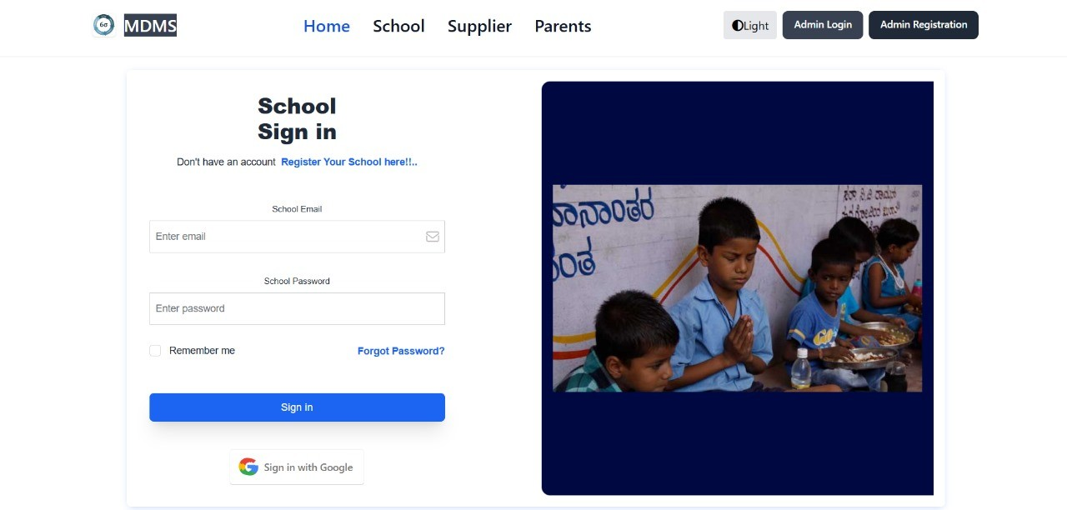

Fig. 1. School Sign in Page

* 1. Real-Time Meal Monitoring
     + Meal Preparation Logging: Staff log meal prepa- ration status in real time, noting any delays or changes.
     + Attendance Tracking: Monitor student attendance during meal times to analyze participation rates. [11]
  2. SMS Notification Workflow
     + Automated Alerts: Daily notifications sent to parents about the day’s meal. Alerts for any changes to the meal schedule or menu. Daily Attendance tracking of their child.
     + Feedback Mechanism: Parents can reply to SMS notifications with feedback or inquiries, which are logged in the system.
  3. Data Analysis and Reporting
     + Consumption Analysis: Generate reports on meal consumption trends, student participation, and parental feedback.
     + Nutritional Assessment: Analyze data to evaluate the nutritional effectiveness of meals provided.
  4. User Interface and Experience
     + Dashboard for School Staff: Provide a user-friendly interface for entering data, viewing meal logs, and accessing reports. [12]
     + Mobile Application: A mobile-friendly version of the system is developed to allow parents to access their child’s information, such as attendance and nutritional status, linked to the unique midday meal ID generated by our system.
       - Parents have separate login credentials, enabling secure access to information specific to their child.
       - The app provides access to meal schedules, nu- tritional details, and attendance records, giving parents real-time insights into their child’s well- being and school meal participation.

1. *Architecture Details*
   1. User Interface Development: HTML, CSS, JavaScript, and Thymeleaf

Fig. 2. Student Profile

* + - 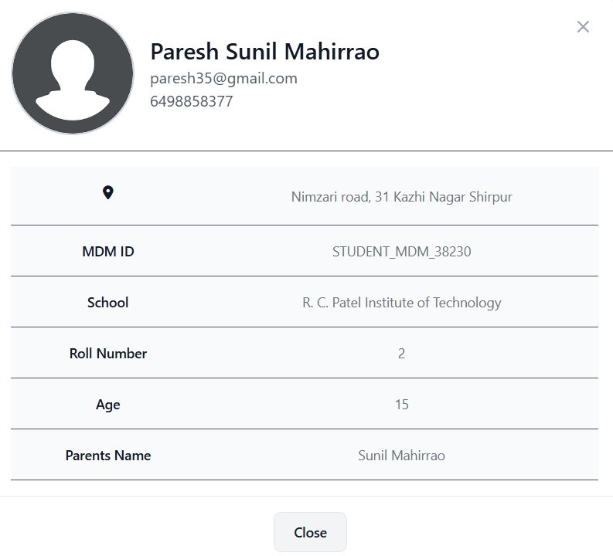HTML, CSS, and JavaScript are employed to build a responsive and interactive user interface, accessible via web browsers on various devices.
    - HTML provides the structural foundation, CSS han- dles styling, and JavaScript adds interactivity to create a dynamic user experience.
    - Thymeleaf, integrated with Spring Boot, serves as the server-side templating engine, allowing dynamic rendering of HTML pages and facilitating the seam- less integration of backend data into the frontend.
  1. Backend Development:
     + Spring Boot serves as the backend framework, pro- viding a robust, scalable, and enterprise-ready solu- tion for building RESTful services. It streamlines development with embedded servers, dependency injection, and easy integration with databases.
  2. Database Management: MySQL
     + MySQL is employed as the database management system, providing a reliable, relational database structure that supports complex querying and data integrity.
     + Its ACID-compliant transactions and structured data storage make it suitable for applications requiring data consistency and reliability.
  3. Frontend Development: HTML, CSS, JavaScript, Thymeleaf, and Tailwind CSS
     + HTML, CSS, and JavaScript are used to create a responsive and interactive frontend, with HTML providing structure, CSS for styling, and JavaScript enhancing interactivity.
     + Thymeleaf, a Java-based templating engine, is used with Spring Boot to dynamically render HTML pages on the server side.
     + Tailwind CSS is integrated to streamline and cus- tomize the styling process, ensuring a responsive and modern UI.

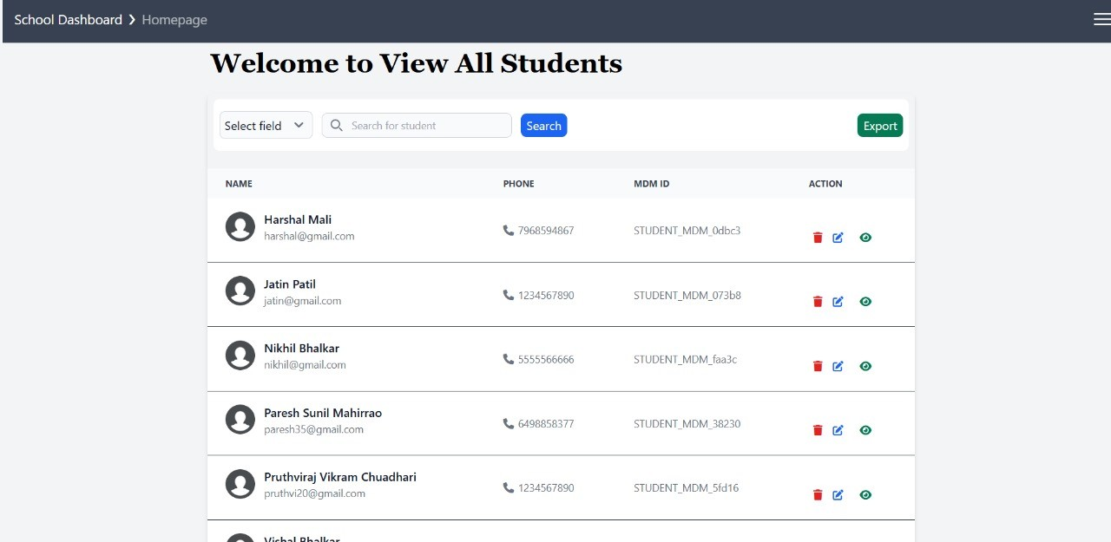

Fig. 3. View Data

* 1. Authentication and Security: Spring Security
     + Spring Security is employed for authentication and authorization, providing robust security measures for the application.
     + It offers features such as role-based access control, password hashing, and protection against common security threats.

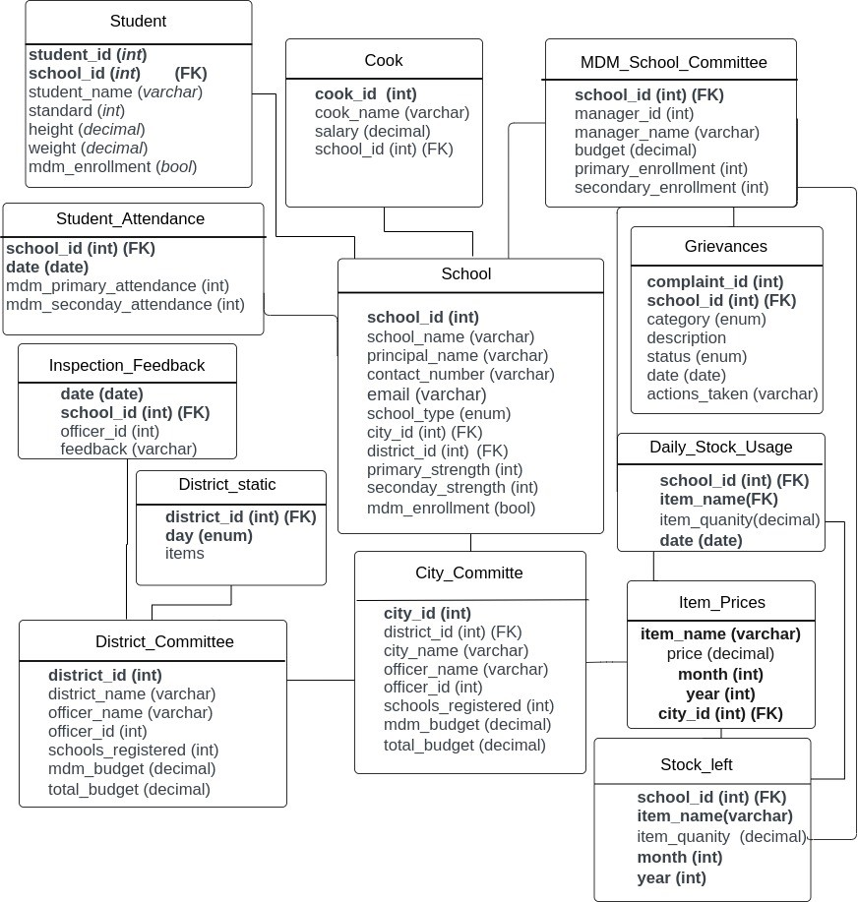

Fig. 4. Schema Representation

1. *Results*
   1. Real-Time Monitoring Efficiency
      * Dashboard Functionality: The centralized dashboard successfully consolidates data from various sources, including meal distribution logs, online attendance

systems. The dashboard provides real-time visual- izations of meal distribution status, delivery sched- ules, and recipient feedback. [13]

* Performance Metrics: During the pilot phase, the dashboard demonstrated a 95 percent accuracy rate in tracking meal distribution times and locations. Real-time updates were achieved with an average latency of less than 5 seconds.
  1. Automated SMS Notification Effectiveness
     + Notification Accuracy and Timeliness: The sys- tem’s SMS notification feature successfully de- livered alerts to parents, school administrators, and other stakeholders. Notifications included meal schedules, delivery confirmations, and emergency alerts.
     + User Feedback: Feedback collected from users indi- cated high satisfaction with the notification system. Over 85 percent of parents reported that they found the notifications useful and timely, contributing to better awareness and planning. [16]
  2. Transparency and Accountability Enhancements
     + Distribution Reports: The system generated detailed reports on meal distribution, including the number of meals served, distribution times, and recipient feedback. These reports facilitated transparency and accountability.
     + Report Accuracy: Report generation was accurate

99 percent of the time, as verified by cross- referencing with manual records.

* + - Usage: Administrators used these reports to iden- tify and address issues promptly, resulting in a 20 percent decrease in reported discrepancies.
    - User Feedback: Feedback collected from users indi- cated high satisfaction with the notification system. Over 85 percent of parents reported that they found the notifications useful and timely, contributing to better awareness and planning.
    - Feedback Mechanism: The integrated feedback mechanism enabled recipients to rate meal quality and report issues. This feature provided valuable insights into meal program performance.
    - Feedback Volume: The system received an average of 150 feedback entries per week, with a response rate of 90 percent for addressing reported issues. [18]
  1. Data-Driven Insights and Analytics
     + Consumption Patterns: The analytics tools provided insights into meal consumption patterns, helping administrators optimize meal preparation and dis- tribution.
     + Optimization Results: Data analysis led to a 10 per- cent reduction in food wastage and a more accurate forecast of meal needs.
     + Historical Data Access: The availability of historical data allowed for trend analysis and better resource planning.
  2. User Experience and Interface
     + Interface Usability: The user interface was designed to be intuitive and user-friendly. Feedback from users indicated ease of navigation and effective access to essential features.
     + User Satisfaction: A usability survey revealed a 92 percent satisfaction rate among administrators and 89 percent among parents regarding the system’s interface and functionality.
     + Mobile Compatibility: The system’s mobile com- patibility ensured accessibility for users on various devices.
     + Usage Statistics: Over 70 percent of users accessed the system via mobile devices, highlighting the importance of mobile-friendly design. [19]
  3. Security and Data Privacy
     + Data Encryption and Access Controls: The system employed encryption and role-based access controls to ensure data security and privacy.
     + Security Compliance: No significant security breaches were reported during the testing phase, and the system complied with data protection regulations.

1. CONCLUSION

In conclusion, the development of a mobile application tailored for the Mid-Day Meal Program represents a significant step towards modernizing and optimiz ing program operations. By integrating features such as real-time SMS notifica tions, meal schedule management, and malnutrition assessment capa- bilities, the application streamlines communication, enhances coordination, and improves efficiency across all stakeholders involved. With its user-friendly interface and comprehensive functionality, the web application serves as a powerful tool in ensuring the smooth implementation of the program, fostering transparency, ac countability, and stakeholder engagement. Moving forward, continuous refine ment and updates to the application based on user feedback and emerging needs will further enhance its effectiveness in supporting the program’s objectives of providing nutritious meals and promoting the well-being of school children.

REFERENCES

1. Elizabeth Abery and Claire Drummond. Implementation of mandatory nutritional guidelines in south australian primary school canteens: a qualitative study. *Improving Schools*, 17(1):41–53, 2014.
2. Farzana Afridi, Bidisha Barooah, and Rohini Somanathan. School meals and student participation in urban india. *Delhi School of Economics*, 2010.
3. Simmi Agnihotri. An assessment of the mid-day meal scheme in india—a study. *Indian Journal of Public Administration*, 56(3):635– 641, 2010.
4. Simmi Agnihotri. An assessment of the mid-day meal scheme in india—a study. *Indian Journal of Public Administration*, 56(3):635– 641, 2010.
5. S Ali. times higher poverty rates in indian households with children: Survey. *Business Standard*, 3.
6. Vijaya Sherry Chand and Samvet Kuril. Contextualising educational decentralisation policies in india. *Economic & Political Weekly*, 53(12):107–114, 2018.
7. Ajit Kumar Dey and Ajoy Bhusan Nath. Nutritional status of school going children (6-15 years) in a semi-urban area of cachar district, assam. *J Evolution Med Dent Sci*, 6(54):4057–62, 2017.
8. Jean Dreze and Aparajita Goyal. Future of mid-day meals. *Economic and political weekly*, pages 4673–4683, 2003.
9. Jean Dre`ze and Geeta Gandhi Kingdon. School participation in rural india. *Review of Development Economics*, 5(1):1–24, 2001.
10. Manisha Garg and Kalyan Sankar Mandal. Mid-day meal for the poor, privatised education for the non-poor. *Economic and Political Weekly*, pages 155–163, 2013.
11. Rajshri Jayaraman and Dora Simroth. The impact of school lunches on primary school enrollment: Evidence from india’s midday meal scheme. 2011.
12. Mohd Zubair Kales. Mid-day meal scheme: A study of different schools of district jammu. *Scholarly Research Journal for Humanity Science and English Language*, 1(5):456–469, 2014.
13. Reetika Khera. Mid-day meals in primary schools: Achievements and challenges. *Economic and political weekly*, pages 4742–4750, 2006.
14. Tattwamasi Paltasingh and Prakash Bhue. Efficacy of mid-day meal scheme in india: challenges and policy concerns. *Indian Journal of Public Administration*, 68(4):610–623, 2022.
15. Tattwamasi Paltasingh and Prakash Bhue. Efficacy of mid-day meal scheme in india: challenges and policy concerns. *Indian Journal of Public Administration*, 68(4):610–623, 2022.
16. Tattwamasi Paltasingh and Prakash Bhue. Efficacy of mid-day meal scheme in india: challenges and policy concerns. *Indian Journal of Public Administration*, 68(4):610–623, 2022.
17. Sushma Sharma, Santosh Jain Passi, Salila Thomas, and Hema S Gopalan. Evaluation of mid day meal programme in mcd schools. *Nutrition Foundation of India, Scientific Report*, 18, 2006.
18. Dipa Sinha. Social audit of midday meal scheine in ap. *Economic and Political Weekly*, pages 57–61, 2008.
19. R Sinha. Rural india: focus on non-agriculture sector. *Live Mint E- Paper*, 2018.